## PAT Procedure Introduction

How Part Average Testing run in SGOS

A new lot testing

When start to test a new lot, the PAT flow would be like this:

1. Start to calculate PAT limit after 20 devices tested.

2. Apply PAT limit to “PASS” dut.

3. Save PAT limits to file when first 200 tested devices reached.

4. Save re-calculated PAT limits base on all tested devices when End-Lot stage.

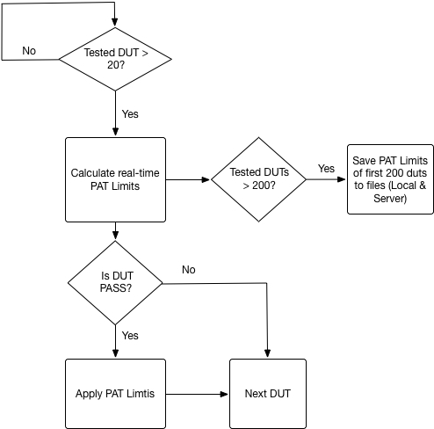

Continue testing which separate from a lot

When continue testing a separate lot which stop from some issue:

1. Try to load a limits file from server/local.

2. If load success, first 20 devices would be apply the old PAT limits. If load fail, it would start like a new lot testing.

3. After first 20 tested devices archived, start to calculate new PAT limits.

4. Save re-calculated PAT limits base on all tested devices when End-Lot stage if the total device numbers is larger than the old limit file.

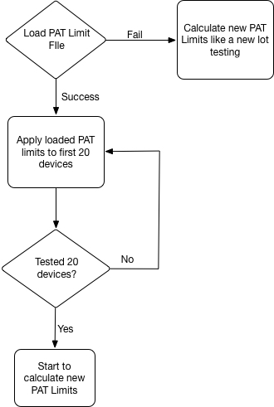

Fail bin re-testing

When re-test the fail bin of a lot:

1. Find to load the PAT limit file of the retest lot. If fail to load, it would alarm to stop the test.
2. Apply the loaded PAT limits to all re-test devices and not to calculate PAT limits.

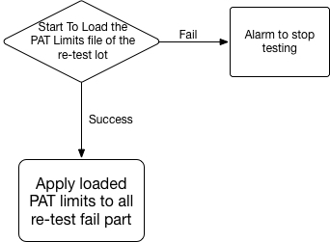

# PAT Limits File存檔規則

原則上盡量保持最大筆數的資料在存檔內，存檔內的header內容如下所示 :

Device: MDFEAAFB095

Lot Number: BH722PP27

SourceDataFile: BH722PP27-01_PF0461704W112-01_CP2_TSG84_20170430111930

Limits Date: 04/30/2017 17:57:16

Parts: 9420

PAT Limits File存檔檔名規則為: DeviceID_LotID.PATLimits

每一LotID只會有一個PAT Limit存檔。而結批時存檔覆蓋原則如下:

1. 新的測試Parts數目必須大於原存檔Parts數的90%。
2. 新的測試Parts數目必須大於1000且新舊數據時間相差三天以上。

以上1或2其中一項成立，即會覆蓋舊的PAT Limits File.